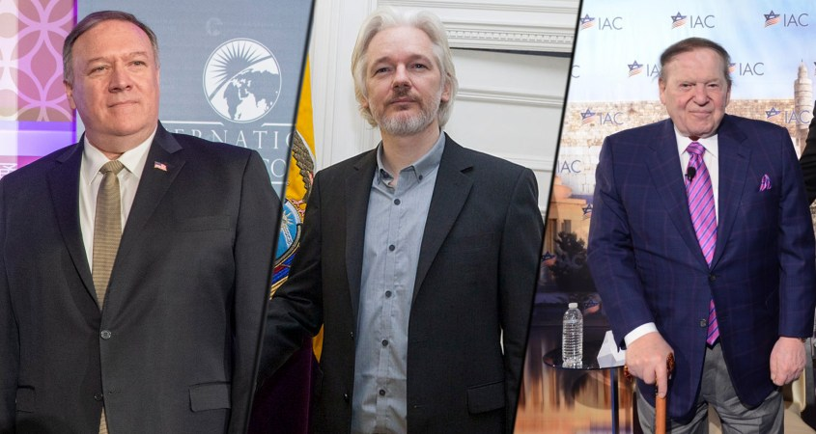
Julian Assange May 14, 2020

‘The American friends’: New court files expose Sheldon Adelson’s security team in US spy operation against Julian Assange

An exclusive investigation by The Grayzone reveals new details on the critical role Sheldon Adelson’s Las Vegas Sands played in an apparent CIA spying operation targeting Julian Assange, and exposes the Sands security staff who helped coordinate the malicious campaign.

By Max Blumenthal
“I was the CIA director. We lied, we cheated, we stole.”
–Mike Pompeo, College Station, TX, April 15, 2019
As the co-founder of a small security consulting firm called UC Global, David Morales spent years slogging through the minor leagues of the private mercenary world. A former Spanish special forces officer, Morales yearned to be the next Erik Prince, the Blackwater founder who leveraged his army-for-hire into high-level political connections across the globe. But by 2016, he had secured just one significant contract, to guard the children of Ecuador’s then-President Rafael Correa and his country’s embassy in the UK.
The London embassy contract proved especially valuable to Morales, however. Inside the diplomatic compound, his men guarded Wikileaks founder Julian Assange, a top target of the US government who had been living in the building since Correa granted him asylum in 2012. It was not long before Morales realized he had a big league opportunity on his hands.
In 2016, Morales rushed off alone to a security fair in Las Vegas, hoping to rustle up lucrative new gigs by touting his role as the guardian of Assange. Days later, he returned to his company’s headquarters in Jerez de Frontera, Spain with exciting news.
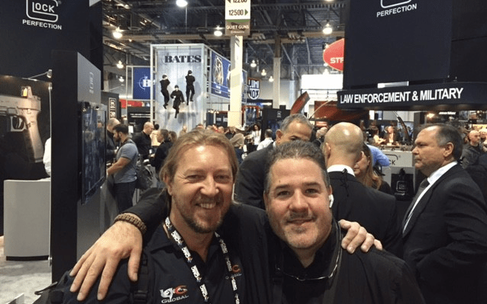UC Global CEO David Morales (left) at a 2016 security fair in Las Vegas
“From now on, we’re going to be playing in the first division,” Morales announced to his employees. When a co-owner of UC Global asked what Morales meant, he responded that he had turned to the “dark side” – an apparent reference to US intelligence services. “The Americans will find us contracts around the world,” Morales assured his business partner.
Morales had just signed on to guard Queen Miri, the $70 million yacht belonging to one of the most high profile casino tycoons in Vegas: ultra-Zionist billionaire and Republican mega-donor Sheldon Adelson. Given that Adelson already had a substantial security team assigned to guard him and his family at all times, the contract between UC Global and Adelson’s Las Vegas Sands was clearly the cover for a devious espionage campaign apparently overseen by the CIA.
Unfortunately for Morales, the Spanish security consultant charged with leading the spying operation, what happened in Vegas did not stay there.
Following Assange’s imprisonment, several disgruntled former employees eventually approached Assange’s legal team to inform them about the misconduct and arguably illegal activity they participated in at UC Global. One former business partner said they came forward after realizing that “David Morales decided to sell all the information to the enemy, the US.” A criminal complaint was submitted in a Spanish court and a secret operation that resulted in the arrest of Morales was set into motion by the judge.
Morales was charged by a Spanish High Court in October 2019 with violating the privacy of Assange and abusing the publisher’s attorney-client privileges, as well as money laundering and bribery. The documents revealed in court, which were primarily backups from company computers, exposed the disturbing reality of his activities on “the dark side.”
Obtained by media outlets including The Grayzone, the UC Global files detail an elaborate and apparently illegal US surveillance operation in which the security firm spied on Assange, his legal team, his American friends, US journalists, and an American member of Congress who had been allegedly dispatched to the Ecuadorian embassy by President Donald Trump. Even the Ecuadorian diplomats whom UC Global was hired to protect were targeted by the spy ring.
The ongoing investigation detailed black operations ranging from snooping on the Wikileaks founder’s private conversations to fishing a diaper from an embassy trash can in order to determine if the feces inside it belonged to his son.
According to witness statements obtained by The Grayzone, weeks after Morales proposed breaking into the office of Assange’s lead counsel, the office was burglarized. The witnesses also detailed a proposal to kidnap or poison Assange. A police raid at the home of Morales netted two handguns with their serial numbers filed off, along with stacks of cash.
One source close to the investigation told The Grayzone that an Ecuadorian official was robbed at gunpoint while carrying private information pertaining to a plan to secure diplomatic immunity for Assange.
Throughout the black operations campaign, US intelligence appears to have worked through Adelson’s Las Vegas Sands, a company that had previously served as an alleged front for a CIA blackmail operation several years earlier. The operations formally began once Adelson’s hand-picked presidential candidate, Donald Trump, entered the White House in January 2017.
In its coverage of the alleged relationship between the CIA, UC Global, and Adelson’s Sands, the New York Times claimed it was “unclear whether it was the Americans who were behind bugging the embassy.” Though he outlined work for an “American client” in company emails, Morales insisted before a Spanish judge that the spying he conducted in the embassy was performed entirely on behalf of Ecuador’s SENAIN security services. He has even claimed to CNN Español that he was merely seeking to motivate his employees when he boasted about “playing in the first division” after returning from his fateful trip to Las Vegas.
This investigation will further establish the US government’s role in guiding UC Global’s espionage campaign, shedding new light on the apparent relationship between the CIA and Adelson’s Sands, and expose how UC Global deceived the Ecuadorian government on behalf of the client Morales referred to as the “American friends.”
Thanks to new court disclosures, The Grayzone is also able to reveal the identity of Sands security staff who presumably liaised between Morales, Adelson’s company, and US intelligence.
According to court documents and testimony by a former business associate and employees of Morales, it was Adelson’s top bodyguard, an Israeli-American named Zohar Lahav, who personally recruited Morales, then managed the relationship between the Spanish security contractor and Sands on a routine basis. After their first meeting in Vegas, the two security professionals became close friends, visiting each other overseas and speaking frequently.
During the spying operation, Lahav worked directly under Brian Nagel, the director of global security for Las Vegas Sands. A former associate director of the US Secret Service and cyber-security expert, Nagel was officially commended by the CIA following successful collaborations with federal law enforcement and intelligence agencies. At Sands, he seemed to be an ideal middleman between the company and the US national security state, as well as a potential guide for the complex surveillance tasks assigned to Morales.
When Adelson’s favored candidate, Donald Trump, moved into the Oval Office, the CIA came under the control of Mike Pompeo, another Adelson ally who seemed to relish the opportunity to carry out illegal acts, including spying on American citizens, in the name of national security.
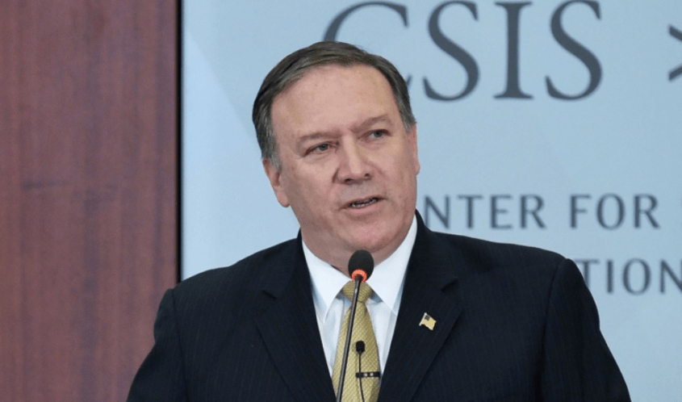

Pompeo outlines the attack on Assange
Pompeo’s first public speech as CIA Director, hosted at the Washington DC-based Center for Strategic and International Studies think tank on April 13, 2017, was one of the most paranoid and resentful addresses ever delivered by an agency chief.
The former Republican congressman from Kansas opened his speech with an extended tirade against the “Philip Agees in the world,” referring to the CIA whistleblower who handed over thousands of classified documents to leftist publishers that revealed shocking details of illegal US regime change and assassination plots around the world.
Alluding to Agee’s contemporary “soulmates,” Pompeo declared, “The one thing they don’t share with Agee is the need for a publisher. All they require now is a smart phone and internet access. In today’s digital environment, they can disseminate stolen US secrets instantly around the globe to terrorists, dictators, hackers, and anyone else seeking to do us harm.”
The CIA director made no secret about the identity of his target. “It is time to call out WikiLeaks for what it really is – a non-state hostile intelligence service often abetted by state actors like Russia,” he rumbled from the podium.
For the next several minutes, Pompeo ranted against Assange, branding him as a “narcissist,” “a fraud,” “a coward.” The right-wing Republican even quoted criticism of the Wikileaks publisher by The Intercept’s Sam Biddle.
Next, Pompeo pledged a “long term” campaign of counter-measures against Wikileaks. “We have to recognize that we can no longer allow Assange and his colleagues the latitude to use free speech values against us. To give them the space to crush us with misappropriated secrets is a perversion of what our great Constitution stands for. It ends now,” he vowed.
Though Pompeo said he recognized that “the CIA is legally prohibited from spying on people through electronic surveillance in the United States,” he seemed to have already put into motion an aggressive program to spy not only Assange, but on his American friends, lawyers, and virtually everyone in his immediate vicinity. Carried out by UC Global, the campaign entailed recording private conversations of US targets, opening their phones, photographing their personal information, and even stealing their email passwords.
The CIA’s apparent attack on Assange had been activated weeks earlier, when Wikileaks announced the publication of the CIA’s Vault 7 files. It would not be long before Adelson’s security team began preparing space for Morales in Las Vegas.

Journey to “the dark side”
On February 26, 2017, Wikileaks announced the forthcoming release of a major tranche of CIA files revealing details of the agency’s hacking and electronic surveillance tools. One such spying application called “Marble” allowed agency spies to implant code that obfuscated their identity on computers they had hacked. Other files contained evidence of programs that allowed hackers to break into encrypted messaging applications like Signal and Telegram, and to turn Samsung smart TVs into listening devices.
Two days after Wikileaks’ initial announcement, on February 28, Morales was junketed from Spain to a hotel in Alexandria, Virginia – just a stone’s throw from CIA headquarters in Langley. Though UC Global had no publicly known contracts with any company in Virginia, court documents obtained by The Grayzone establish that Morales sent encrypted emails from an Alexandria IP address and paid bills from a local hotel for the next eight days.
From that point on, he traveled back and forth almost each month between Spain, the DC area, New York City, Chicago, or the Las Vegas base of Adelson’s operations.
When in DC, Morales sent emails from a static IP address at the Grand Hyatt Hotel just four blocks from the White House.
The Instagram posts of Morales’ wife and travel partner, Noelia Páez, highlighted the frequency of his trips:
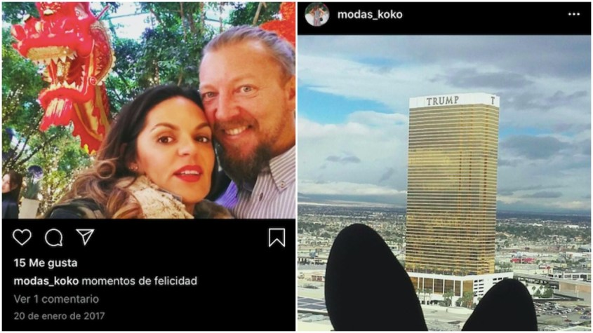Instagram posts by Morales’ wife, Noelia Páez, posted while in Las Vegas on January 20, 2017
Fellow UC Global executives began to grow suspicious of Morales and his secretive dealings in the US. According to their testimonies, he spoke constantly about his working relationship with the Americans. Yet UC Global had been contracted by Ecuador’s intelligence agency, SENAIN, to provide security to the country’s embassy in London – not to spy on its occupants.
It was increasingly clear to them that Morales was deceiving one client in Quito to serve a more powerful force in Washington.
“I remember that David Morales asked a person from the company to prepare a safe phone, with safe applications, just like an encrypted computer to communicate with ‘the American friends,’ to take his relationship with the US out of the company’s range,” a former UC Global employee recalled.
A former business partner at UC Global stated in their testimony, “Sometimes, when I insistently asked him who his ‘American friends’ were, on some occasions David Morales answered that they were ‘the US intelligence.’ However, when I asked him for a particular person from intelligence he was meeting with to give them information, Mr. Morales cut the conversation and pointed out that the subject was exclusively managed by him aside from the company.”
The ex-partner suspected that Morales was receiving payments from US intelligence through a bank account managed by his wife, Páez. “On one occasion,” they testified, “I heard a conversation related to payments to that account from which Mr. Morales didn’t want to inform the rest of the company members about.”
Suspicion turned to rage when the former UC Global partner recognized the full extent of Morales’ subterfuge. “I started [lashing out] at him openly in violent discussions in which I reiterated to him that a company like ours is based on ‘creating trust’ and that he can’t ‘give out information to the opposing side,’” the ex-associate recalled. At the end of several such arguments, he said Morales tore open his shirt, puffed out his chest and exclaimed, “I am a wholehearted mercenary!”

One camera feed for Ecuador, another for “the American client”
Two former UC Global workers and the ex-business partner said Morales began implementing a sophisticated spying operation at the embassy in London in June 2017. His testimony was corroborated by emails Morales sent to employees who oversaw the surveillance.
Before that point, the cameras in and around Ecuador’s embassy in London were standard CCTV units. Their sole function was to detect intruders. Most importantly, they did not record sound.
To transform the cameras from security instruments into weapons of intrusion, Morales emailed a friend, “Carlos C.D. (spy),” who owned a surveillance equipment company called Espiamos, or, “We Spy.” He informed Carlos that “our client” demanded new cameras be placed in the embassy that were equipped with undetectable microphones.
On the 27th of the same month, Morales wrote to the same employee: “the client wants to have streaming control of the cameras, this control will have to be possessed from two different locations.” He requested a separate storage server that could be operated “from out of the enclosure where the recorder is located.”
By altering the cameras so they could be controlled from the outside, and outfitting them with hidden microphones, Morales put in place the mechanism to snoop on Assange’s intimate conversations with friends and lawyers. He also took steps to feed the footage to a separate, exterior storage server, thus keeping the operation hidden from Ecuador’s SENAIN. His marching orders came from an organization he described simply as “the American client.”
Every 15 days or so, Morales sent one of the workers to the embassy to collect DVR recordings of the surveillance footage and bring it to company headquarters in Jerez, Spain. Some important clips were uploaded to a server named “Operation Hotel,” which was later changed to a website-based system. In cases when the DVR size was too large to upload, Morales personally delivered it to his “client” in the US.
In December 2017, Morales was summoned to Las Vegas Sands for a special session with “the American friends.” On the 10th of that month, he sent a series of emails from a static IP address at Adelson’s Venetian Hotel to his spy team. The messages contained a new set of instructions.
“Nobody can know about my trips, mainly my trips to the USA,” Morales emailed his employees, “because SENAIN is onto us.”
To further limit the Ecuadorian government’s access to the surveillance system installed in the embassy, he instructed his workers, “We can’t give them access to some of the program’s services, so they don’t realize who has more log-ins or who is online inside the system… [but] everything must look like they have access to it.”
Morales sent his team a powerpoint presentation containing instructions for the new system. The aim of the instructions was to create two separate users: an administrator for the Ecuadorian client with no access to the log-in so they would not be able to notice the second user; and a separate security log-in for the Americans, who would be in full control of the system’s surveillance features.
Obtained by The Grayzone, the slides were composed in perfect English by a native speaker who was clearly not Morales.
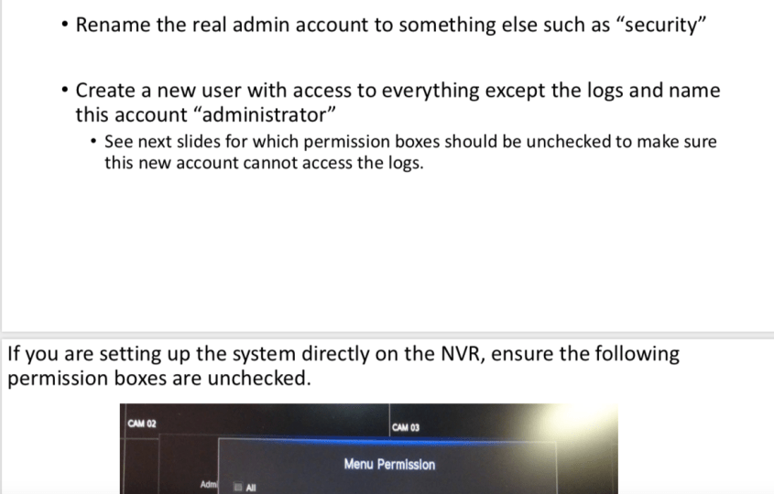From the powerpoint surveillance instructions provided to Morales by the “American client” while he stayed at Adelson’s Venetian hotel in December 2017
“David Morales obviously didn’t have the technical knowledge,” a former UC Global IT specialist who received the instructions, “so the document must have been sent by another person. Because it was in English, I suspect that it could’ve been [created by] US intelligence.”
Whoever authored the powerpoint instructions was clearly an expert in cyber-security with experience in electronic surveillance and hacking. That person demonstrated their tradecraft by erasing all of the document’s metadata except for the username, “PlayerOne.” The powerpoint was handed down in the apparent physical presence of Morales, who proceeded to tell his employees, “these people have given me the following instructions, drafted in English.”
In Adelson’s orbit, there was at least one cyber-security expert with a long record of collaboration with US law enforcement and intelligence: senior vice president and global head of security at Las Vegas Sands, Brian Nagel.

From top US cyber-crime investigator to Adelson’s security chief
During his lengthy career in the US Secret Service, Nagel worked at the nexus of federal law enforcement and US intelligence. In the 1990s, Nagel not only served on the personal protection detail of Presidents George H.W. Bush and Bill Clinton; he was assigned to “work with two foreign protective services after the assassination and attempted assassination of their respective heads of state,” he said in sworn testimony in a US District Court in 2011. Nagel also stated that he later protected the director and deputy director of a federal agency that he neglected to name.
During the same testimony, Nagel said he received the CIA’s Intelligence Community Seal Medallion, an award given to non-CIA personnel “who have made significant contributions to the Agency’s intelligence efforts.”
As the deputy director of the Secret Service, he appeared alongside then-US Attorney General John Ashcroft at a November 2003 press conference on combating cybercrime, and testified before the House Homeland Security Subcommittee in March 2007. Besides those two public events, Nagel has not appeared on camera.
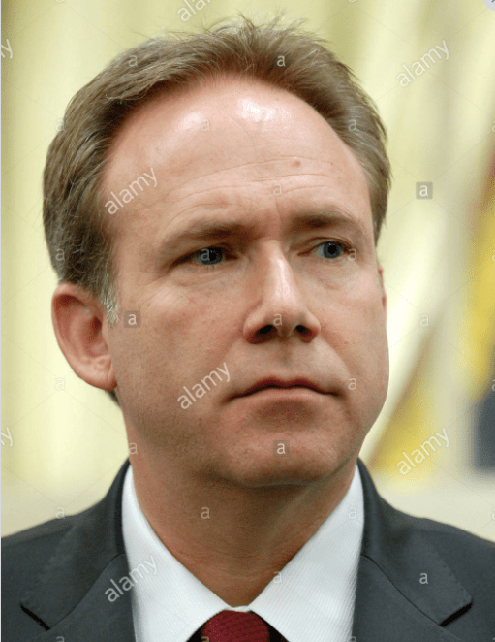One of just a few publicly available photos of Las Vegas Sands Director of Global Security Brian Nagel, from his congressional testimony in 2007
While the public tends to associate the US Secret Service with burly men in dark suits and aviator shades who whisper into their sleeves while shadowing presidents, the agency also functions as the country’s leading computer crime investigative body.
In November 2002, the LA Times reported on Nagel’s role in creating the Los Angeles Electronic Crimes Task Force, a massive federal operation that occupied an entire floor of a downtown LA skyscraper. Dedicated to fighting electronic crime and cyber terrorism, the task force included the FBI, local law enforcement, private security contractors, and the US Secret Service. The initiative, said Nagel, “was all about enhancing our current partnerships and building new ones.”
In October 2004, Nagel was credited with taking down a major international cybercrime outfit called shadowcrew.com (no relation to the Shadow Brokers hacker outfit that leaked NSA secrets). According to TechNewsWorld, under Nagel’s watch, “The Secret Service used wiretaps, an undercover informant and their own hackers to gain access to the private portions of the [shadowcrew] site.”
These tactics seemed remarkably similar to those deployed 13 years later to spy on Assange.
Before leaving public life in 2008, Nagel helped the Department of Homeland Security (DHS) create the National Computer Forensic Institute. Then-DHS Director Michael Chertoff vowed the institute would “turn the tables on criminal groups” by empowering law enforcement to use “the same technologies” hackers and cyber-criminals typically employed.
Two years later, when Wikileaks first appeared, the special federal cyber-security units Nagel helped create were likely on the frontlines of the US fight to combat Assange’s online information clearinghouse.

Adelson’s Israeli-American bodyman turns spying middleman
When Nagel joined Las Vegas Sands as its global security director, he was placed in charge of securing an international financial and political empire that spanned from the US to Israel to Macau in the People’s Republic of China. Sands chairman Sheldon Adelson possessed a fortune valued at around $30 billion that placed him consistently in the top 10 of Forbes’ list of the wealthiest Americans.
Adelson’s political activities were guided by two factors: his desire to expand his gambling operations around the globe, and his fanatical Zionism. He is so committed to the self-proclaimed Jewish state, he once lamented having served in the US Army as a young man rather than in Israel’s military.
As a personal friend and financial benefactor of Israeli Prime Minister Benjamin Netanyahu, Adelson plowed his money into a failed attempt to prevent President Barack Obama’s re-election and halt the signing of the Iran nuclear deal. In 2016, he became a top donor to Trump’s presidential campaign, helping to cultivate the most pro-Likud administration in US history.
To ensure his personal protection, Adelson assembled a collection of former Israeli soldiers and intelligence officers as bodyguards. At the head of his security detail was Zohar Lahav, an Israeli citizen who served as the vice president for executive protection at Las Vegas Sands.
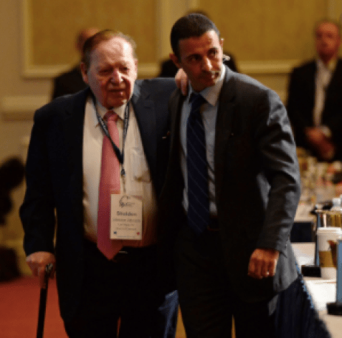Adelson with a top bodyguard
Naturalized in the US, Lahav worked for a period in the 1990s as an administrator at the Israeli consulate in Miami. He was the subject of minor controversy in 1996 when the Miami New Times reported that the city of Miami had hired him as sergeant-in-arms, entrusting him with protecting the mayor along with an array of undefined roles, including personal aide.
Lahav found himself in the news again in 2011 when nine members of Adelson’s executive team sued his employer at Las Vegas Sands for refusing to pay them overtime. Three of the staffers amended the lawsuit to allege that they were denied promotions because they were African American.
“The [executive protection team], for all of its 14 years of existence, has been managed and controlled by an executive management team which has been comprised exclusively of former Israeli citizens who are white males,” their lawyer complained. (Besides Lahav, the legal complaint named Adi Barshishat as an Israeli who helped direct Adelson’s security team. On his LinkedIn profile, Barshishat lists extensive training surveillance by an unnamed “Israeli Government Agency.”)
In their complaint against Sands, the plaintiffs alleged that Lahav routinely told racially charged jokes. One of them accused Lahav of forcing team members to “transport firearms in violation of state law” and making them operate an unregistered x-ray machine that placed their health in danger. Two of the security guards subsequently sued Adelson for causing them to “suffer injuries, including sterilization,” by forcing them to x-ray every piece of the billionaire’s mail. Lahav was also accused of ordering security staff not to communicate with Brian Nagel under any circumstance.
Sands retaliated swiftly against the disgruntled security guards, reassigning them to humiliating mall cop-style roles. Next, Adelson’s attorney accused the opposing counsel of anti-Semitism, claiming he had harassed Lahav with “insulting questions about race, his religion,” and Adelson’s family. Finally, Nagel pushed to prevent the legal proceedings from being filmed, insisting before a district judge that televised coverage would “create material for viral use on the internet by extremist hate groups and terrorists” that could result in harm to Adelson’s personal safety.
It was an ironic claim by a security operative whose company appeared to have participated in a highly intrusive and possibly illegal spying operation against Assange and numerous lawyers, journalists, politicians, US citizens, and Ecuadorian diplomats.

A CIA front in Chinese territory?
By the time of the lawsuit, Adelson’s company appeared to have been working closely with the CIA. A confidential 2010 report by a private investigator contracted by the gambling industry pinpointed Adelson’s casino in Macau as a front for Agency operations against China.
“A reliable source has reported that central Chinese government officials firmly believe that Sands has permitted CIA/FBI agents to operate from within its facilities. These agents apparently ‘monitor mainland government officials’ who gamble in the casinos,” it stated.
Previously detailed by the Guardian in 2015 and viewed by The Grayzone this May, the confidential report cited evidence from Chinese official sources of “‘US agents’ operating from Sands, ‘luring’ and entrapping mainland government officials, involved in gaming, to force them to cooperate with US government interests.”
A spokesman for Adelson’s Sands issued a non-denial denial of the report, dismissing it as “an idea for a movie script.” Not long after, another collaboration between Adelson and Langley seemed to be in the works, and it too contained all the elements of a blockbuster spy thriller.

“I sense that this person offered him to collaborate with American intelligence authorities”
A 2016 security industry fair in Las Vegas at the Sands Expo provided the occasion for Adelson’s company – and presumably the CIA – to enlist David Morales. His personal recruiter, according to witness testimony, was Lahav.
When Morales returned from Vegas to his home base in Spain, he divulged details of the deal to his then-business partner.
“I deduced from the conversations with David Morales, where he confessed in detail his agreements achieved at his US trip,” the ex-partner later testified in Spanish court, “the head of security of Las Vegas Sands, a Jewish guy named Zohar Lahav, made contact with Mr. Morales, getting to become good friends with him at the security fair in Las Vegas. I sense that this person offered him to collaborate with American intelligence authorities to send information about Mr. Assange.”
Morales confirmed his and Lahav’s close friendship during an interview in Spanish court conducted this February by Aitor Martinez, a Spanish lawyer representing Assange in the case. In an earlier court appearance, the Spanish prosecutor asked Morales directly about the connection between Lahav and US intelligence services; Morales claimed he had no idea.
A former business partner of Morales recalled an incident “when Zohar [Lahav] came to Spain and stayed at [Morales’] usual house for a week.”
Further evidence of the relationship between Lahav and Morales can be found in an undated recommendation letter Lahav wrote for his pal. Authored on Sands letterhead, Lahav stated that he had “worked with Mr. David Morales CEO in UC Global S.L. for 3 years,” praising him for his “loyalty and consistency.”
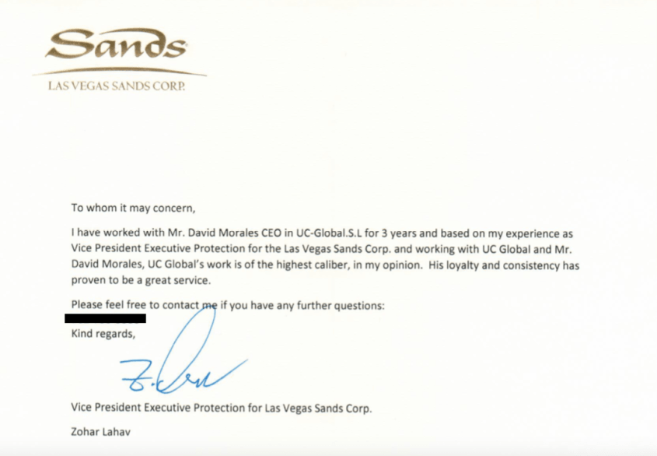
By the end of 2017, the alleged collaboration between Morales and Sands had fully matured, with the CIA apparently providing a guiding hand. Together, these entities ratcheted up their surveillance of Assange’s associates and foiled his plan to leave the embassy under the protection of diplomatic inviolability.

Spying, stealing diapers, and burglary plans
Stefania Maurizi, an Italian journalist who visited Assange regularly at the embassy in London, remembered relaxed encounters with minimal security and friendly interactions with embassy staff for the first five years of the Wikileaks founder’s stay. It was in December 2017 that everything changed.
During a visit to interview Assange that month, the Spanish security guards from UC Global demanded Maurizi hand over her backpack and all belongings inside for the first time. She protested the new and seemingly arbitrary procedure, but to no avail.
“They seized everything,” Maurizi told The Grayzone. “They took my two telephones, one which was encrypted; my iPod, and many USB sticks. There was no way to get my backpack back. The guard told me, ‘Don’t worry, everything will be fine, no one will access your materials or open your backpack.’ I was very suspicious. I wasn’t even allowed to bring a pen inside to take notes.”
It turned out that UC Global employees photographed the unique International Mobile Equipment Identity number and the SIM card number inside the phone of Maurizi and many other visitors. In one photograph obtained by The Grayzone, the security contractors removed the SIM to get a clear image of the codes. It seemed this was the information they needed to hack the phones.
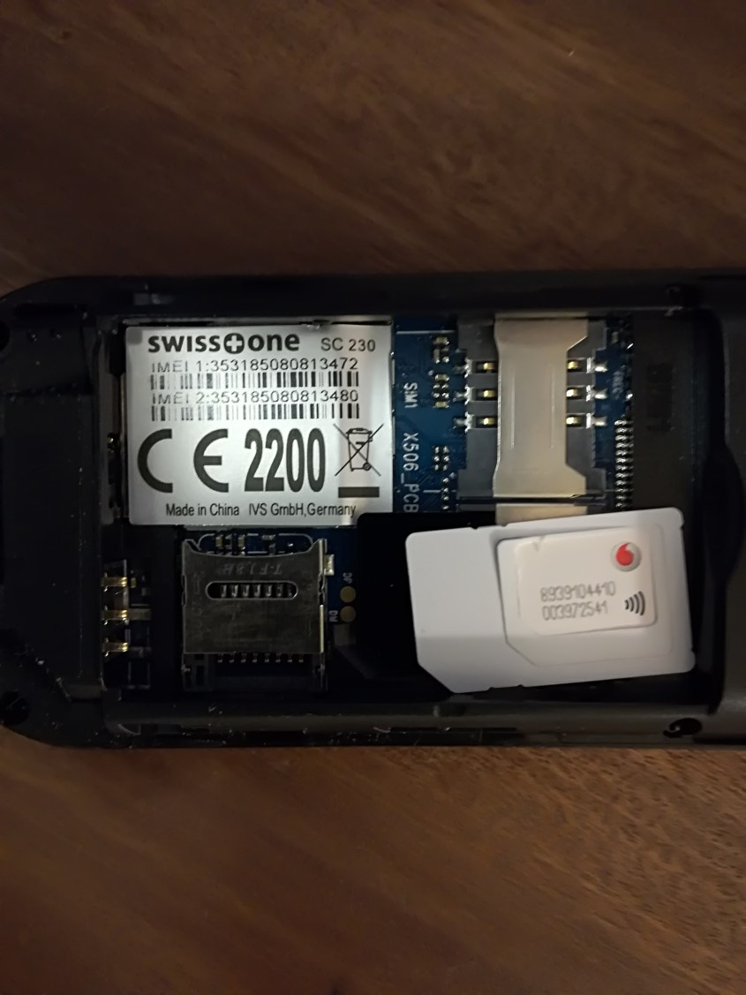UC Global photo of journalist Stefania Maurizi’s mobile phone
Maurizi knew nothing at the time about the relationship currently under investigation between the CIA and the security team at the embassy. She was only aware that Correa, the leftist president of Ecuador who advocated for Assange, had been succeeded months earlier, in May 2017, by Lenin Moreno, his former vice president whom he branded as a Trojan horse for US interests.
The new administration took a sudden pro-US turn that mandated hostility towards Assange and his organization. As the IMF dangled a massive loan before his cash-strapped government, Moreno denigrated Assange as a “hacker” and cut off his internet access as well as visits from the outside for a prolonged period.
Assange, for his part, had become convinced that the embassy security was spying on him. By late 2017, he was using a white noise machine in the main conference room to keep his conversations with lawyers secure, and held the most sensitive meetings with his attorneys in the women’s bathroom, opening the faucets to drown out the sound of their conversations. UC Global countered by planting a magnetic microphone on the bottom of a fire extinguisher, enabling them to snoop through the white noise. A second microphone was installed in the women’s bathroom.
Other plans exposed in UC Global company emails called for planting a mic capable of listening through walls, and placing it secretly inside the office of the ambassador, who was referred to in emails as “Director of the Hotel.”
Morales also proposed installing listening devices in Assange’s bedroom, and even put a program in place to swap out all fire extinguishers and replace them with new ones with hidden mics. The mic in the main conference room recorded the bulk of conversations, and is currently in the possession of the Spanish judge overseeing the case.
“Julian was extremely worried. He said the guards were working for intelligence,” his lawyer, Martinez, recalled. “I told him they were just working-class guys from southern Spain, where I’m from. But now I realize he was totally right.”
On December 12, two days after receiving the powerpoint instructions at Las Vegas Sands on creating separate surveillance camera feeds, Morales sent an email to his embassy spy team identifying specific individual targets. According to a former UC Global worker, the list was created by “the Americans.”
Among the first he ordered them to focus on was “Fix,” a German cyber-security expert; and “MULLER,” a reference to Andrew Müller-Maguhn, a German hacker and internet rights activist who was close friends with Assange. On a visit to the embassy, UC Global security photographed the contents of Müller-Maguhn’s backpack and the contact numbers in his mobile phone.
Morales also demanded the surveillance of Ola Bini, a Swedish software developer who visited Assange, and Felicity Ruby, a colleague of Bini at the company ThoughtWorks, which Morales described as “a team of hackers.”
In a September 2017 bulletin, Morales issued a list of 10 individual targets for investigation, demanding updated profiles on Assange lawyers such as Renata Avila, Jennifer Robinson, and Carlos Poveda, as well as Spanish judge Baltasar Garzon.
Morales urged “special attention” to Stella Morris, a member of the legal team who recently revealed she began a relationship with Assange and had two children with him during his time in the embassy. After proposing “a person thoroughly dedicated to the activity” of spying on Morris, Morales eventually instructed an employee to steal a diaper from one of Morris’ infant sons in order to extract DNA which could prove she was the mother of Assange’s children. “At the time,” the employee testified, “Morales deliberately indicated that ‘the Americans’ insisted in confirming [the DNA results].”
Upset by the bizarre assignment, the UC Global staffer eventually intercepted Morris outside the embassy to inform her about the planned diaper theft and to warn her against taking the child inside.
“They were obsessed with American visitors, all of them, from lawyers to journalists to friends. They focused a lot on Glenn Greenwald, even opening his passport, taking pics of his visa to Russia and sending it to their headquarters,” Martinez said, referring to the Brazil-based, American journalist who had visited Assange. (The Grayzone has viewed UC Global’s photo of the entry visa in Greenwald’s passport.)
The December 12 email from Morales also called for attention to any “Russian citizens” visiting Assange. The directive seemed to reflect the growing American obsession with connecting Wikileaks to Russian intelligence and the alleged hacking of the Democratic National Committee email servers in 2016.
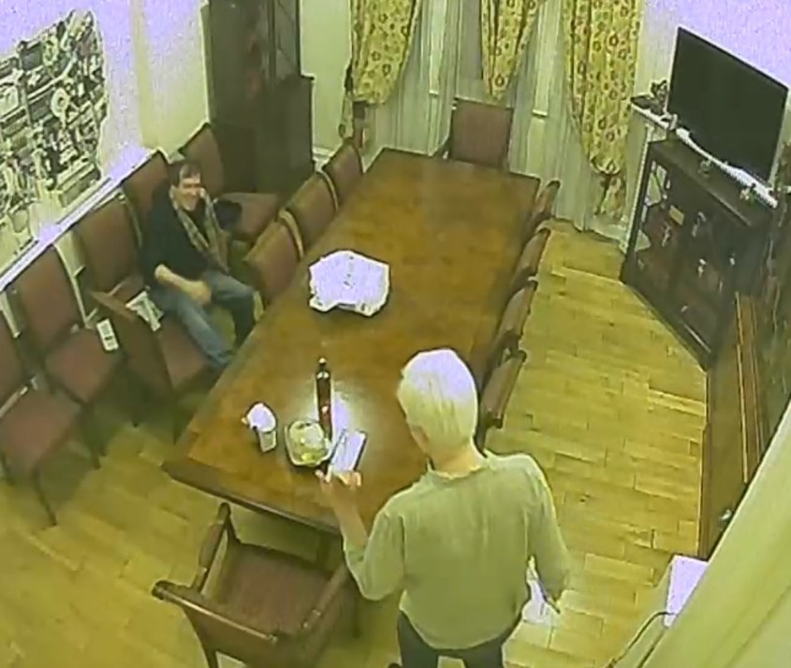UC Global spy footage of comedian and activist Randy Credico visiting Julian Assange in November 2017
As a result of the ramped-up surveillance, Garzon, the Spanish judge who led Assange’s legal team, was followed by UC Global spies when he picked up former Ecuadorian President Correa at Barajas Airport in Madrid, Spain. The two were photographed while at Garzon’s home. Morales subsequently emailed a report and photographs of the meeting.
A former UC Global employee testified that in November 2017, Morales proposed breaking into the Garzon’s Madrid office in order “to obtain relevant information about Mr. Assange and giving it to [the Americans].” The ex-staffer noted that two weeks later, Garzon’s office was burglarized and no money or valuables were taken. The Spanish daily El Pais reported that three hooded men dressed in black broke into Garzon’s office on December 18, 2017, took no money, but “shuffled through documents.”
All surveillance, tracking, and communications requests on Baltasar Garzón, according to what David Morales said, “came from the Americans,” the former employee testified.
Morales also sent reports about a meeting Correa held in Brussels, with details of the serial numbers of his devices, intimate information on the people he met, and the content of those conversations. Strangely, the report was drafted by Morales in English and sent to his team in order to be shared on the special server created for the “American client.” He claimed implausibly that the report was for Ecuador’s SENAIN.
Yet when he was asked by the prosecutor and by Martinez, the lawyer for Assange, why he composed an email to Spanish-speaking Ecuadorian officials in English, Morales struggled for an excuse. “Sometimes I like to write in English,” he claimed.
Maurizi, for her part, found that calls, emails, and texts from her editors, then at the Italian daily La Repubblica, were failing to go through. “No one could explain this disruption,” Maurizi said. “I wonder if it had anything to do with these espionage activities. To this day I cannot say.”
Meanwhile, Pamela Anderson, the American actress who became a friend of Assange, had her email and mobile phone passwords stolen by UC Global during a visit. The theft occurred when Anderson wrote her passwords on a notepad so Assange could verify the security of her accounts. With the camera system they installed, UC Global spies managed to photograph the pad, allowing them access to her accounts.
The spying dragnet ensnared virtually everyone who entered the embassy, even then-US Representative Dana Rohrabacher. Assange’s lawyer Jennifer Robinson attended the August 2017 meeting with Rohrabacher and claimed he announced himself as an official emissary of Trump. She said the congressman offered a presidential pardon on the condition that the Wikileaks publisher could provide concrete evidence the Russian government did not hack the DNC’s email server.
Rohrabacher later admitted that he dangled the possibility of a pardon, but maintained his visit was a personal “fact-finding mission” unrelated to any Trump initiative.
A former UC Global worker testified that “the Americans were very nervous about the visit” by Rohrabacher, and “personally asked Morales to control and monitor absolutely everything related to that visit.” During the meeting, Rohrabacher was required to leave his phone with UC Global spies.

Sabotaging Assange’s exit strategy, robbery and assassination plots
Throughout December 2017, Assange and his lawyers were formulating a plan to exit the embassy under the protections granted to diplomats under the Vienna Convention on Diplomatic Relations. One proposal called for appointing Assange as a diplomat for a friendly government like Bolivia or Serbia, thus guaranteeing him diplomatic immunity. The final component of the plan relied on cooperation from the head of Ecuador’s SENAIN, Rommy Vallejo, who was technically the boss of Morales. Vallejo arrived at the embassy on December 20, 2017 – just five days before Assange planned to leave the embassy.
“It was the last step,” said Martinez of the visit by the SENAIN chief. “[Vallejo] was going to speak with Julian [Assange] about final details to leave the embassy and arrange a diplomatic vehicle. Now, after checking all the records and emails, we found that when he visited Julian, Morales told [his spy team] to record everything, open all the cameras, and take all data of all telephone mobiles.”
Indeed, as soon as the meeting was finished, Morales asked his employees to send the full surveillance records to him by Dropbox. The UC Global team proceeded to open Vallejo’s phones and take his mobile codes.
On December 21, the day after Assange’s meeting with the SENAIN chief, US prosecutors secretly filed charges against Assange in federal court in Alexandria, Virginia.
According to a source involved in the plan to grant Assange diplomatic immunity, the US ambassador to Ecuador, Todd Chapman, informed Ecuadorian authorities that he had learned of the initiative, and warned them against executing it.
The source also told The Grayzone that when one of the Ecuadorian officials involved in conceiving the strategy to free Assange from the embassy returned to Quito, his official government vehicle was stopped on a road by masked gunmen on a motorcycle who robbed him of his laptop. The computer contained detailed information about the plan to legally allow Assange to leave the embassy.
Guillaume Long, the foreign minister of Ecuador under Correa, told The Grayzone that the US-coordinated spying operation targeting Assange at the Ecuadorian embassy was “a major breach of sovereignty, of international law and the rules by which international diplomacy is regulated. And it’s completely illegal and, I would argue, really undermines the US case for the extradition of Julian Assange.”
The alleged robbery of an Ecuadorian official in Quito was consistent with another violent plan divulged by a former UC Global employee in the Spanish court.
The ex-staffer recalled Morales mentioning that “the Americans were desperate” to end Assange’s presence in the embassy. Thus they were “proposing to activate more extreme measures against him,” including “the possibility of leaving one diplomatic mission door open, arguing that it was an accidental mistake, to allow the entrance and kidnapping of the asylum seeker; or even the possibility of poisoning Mr. Assange.”
The staffers were shocked when they learned of the proposal and protested to Morales that the direction he was taking “was starting to get dangerous.”

After a campaign of espionage, an Espionage Act prosecution
On April 11, 2019, British police raided the Ecuadorian embassy in London and dragged Assange into a waiting van. It was the first time in history a government had allowed a foreign law enforcement agency to enter its sovereign territory to arrest one of its citizens.
That same day, Ola Bini – the Swedish computer programmer branded as a “hacker” by Morales and placed under apparent US surveillance – was arrested in Ecuador and detained for months without charges. Accused of collaborating with Assange and various cyber-crimes, Bini has been held in Ecuador’s El Inca prison, where US authorities have reportedly requested to interrogate him. Amnesty International has labeled Bini a “digital defender” and condemned “undue government interference” as well as the intimidation of his legal defense team.
Assange, an Australian citizen, was subsequently jailed in Belmarsh Prison, where he now awaits possible extradition to the US and trial for 18 charges, 17 of which relate to violating the Espionage Act. The charges carry a maximum penalty of 175 years in prison.
During the first extradition hearing this February 24, Assange was confined to a glass box that prevented him from directly conferring with his lawyers. Observers including former British diplomat Craig Murray said they noticed US agents conferring outside the courtroom with UK prosecutors.
One witness to the extradition hearing provided The Grayzone with photographs of several attendees they claimed were US Department of Justice officials who sat directly behind British prosecutors throughout the proceedings. The photos, seen below, show the alleged officials outside the courtroom.
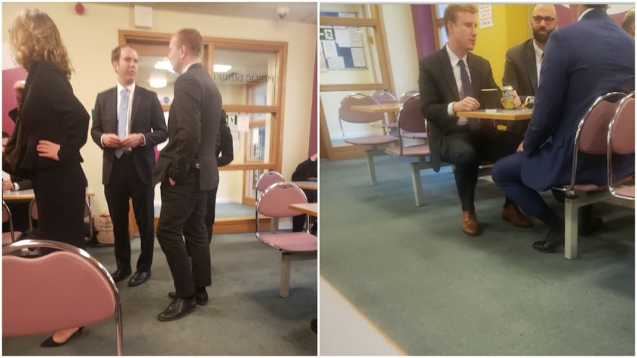After the hearing began, according to Assange’s lawyer, Martinez, a female British barrister arrived and demanded permission to observe. She was representing Las Vegas Sands, a clear indication that Adelson was deeply concerned about the outcome of the proceedings.
Having been promoted from CIA director to secretary of state, Mike Pompeo has reportedly laid the groundwork to run for US senate in Kansas. The first step in Pompeo’s fledgling campaign, according to a raft of articles, was outreach to Sheldon Adelson to “gauge interest” in financing the Senate bid.
By the end of 2019, following the exposure of Sands’ relationship with UC Global, former employees of Morales revealed a rumor that Adelson’s bodyguard, Zohar Lahav, had been fired by Las Vegas Sands. When Morales was asked during an appearance before the Spanish court this February if the rumor was true, he confirmed it, stating that Lahav was terminated because of the “mess” that he helped create.
Reached by phone by The Grayzone on May 12, Lahav immediately hung up when told he was speaking with a reporter.
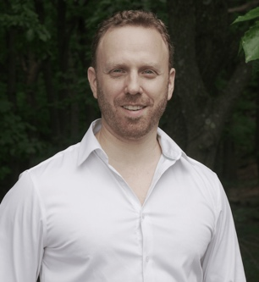
Max Blumenthal
Max Blumenthal is an award-winning journalist and the author of several books, including best-selling Republican Gomorrah, Goliath, The Fifty One Day War, and The Management of Savagery. He has produced print articles for an array of publications, many video reports, and several documentaries, including Killing Gaza. Blumenthal founded The Grayzone in 2015 to shine a journalistic light on America’s state of perpetual war and its dangerous domestic repercussions.
thegrayzone.com

PS by jones@networkers.org: According to its own web site Las Vegas Sands (LVS) “is the pre-eminent developer and operator of world-class Integrated Resorts that feature luxury hotels; best-in-class gaming; retail; dining and entertainment; Meetings, Incentive, Convention and Exhibition (MICE) facilities; and many other business and leisure amenities.”

